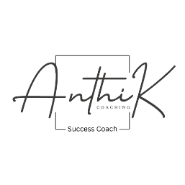
Client Intake / Assessment Questionnaire
Anthi K Coaching – Success Coach & Personal Life Trainer

Client Name: Click or tap here to enter text.
Pronouns: Click or tap here to enter text.
Date: Click or tap here to enter text.
1. Background Information
- Age / Grade / Profession:Click or tap here to enter text.
- Current life situation (briefly describe): Click or tap here to enter text.
- Hobbies, interests, strengths: Click or tap here to enter text.

2. Coaching Goals
- What are your top 3 goals for coaching?
  - Click or tap here to enter text.
  - Click or tap here to enter text.
  - Click or tap here to enter text.
- What obstacles or challenges are preventing you from achieving these goals?
Click or tap here to enter text.
Click or tap here to enter text.
- What would success look like for you at the end of coaching?
Click or tap here to enter text.

3. Mindset & Habits
- How would you describe your current motivation level? (1–10) Click or tap here to enter text.
- What habits or routines are helping or holding you back?
Click or tap here to enter text.
- What skills or areas do you want to improve?
Click or tap here to enter text.

4. Support & Preferences
- How do you prefer to receive support between sessions?
☐ Email ☐ Text ☐ Phone call ☐ Other: Click or tap here to enter text.
- Preferred session format: ☐ In-Person ☐ Virtual ☐ Hybrid
- Anything else you’d like me to know?
Click or tap here to enter text.

