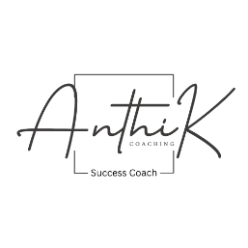
Session Follow-Up & Summary Form
Anthi K Coaching – Success Coach & Personal Life Trainer

Client Name:Click or tap here to enter text.
Session #:Click or tap here to enter text.
Date: Click or tap here to enter text.
Coach:Click or tap here to enter text.

1. Session Summary
- Key topics discussed:
Click or tap here to enter text.

- Insights or breakthroughs:
Click or tap here to enter text.
Click or tap here to enter text.
Click or tap here to enter text.
2. Progress Review
- Goals from previous session:
Click or tap here to enter text.
- Achievements / milestones reached:
Click or tap here to enter text.
- Challenges or obstacles encountered:
Click or tap here to enter text.
Click or tap here to enter text.
3. Action Steps & Assignments
- Action items for client before next session:
  - Click or tap here to enter text.
  - Click or tap here to enter text.
  - Click or tap here to enter text.
- Coach support / resources to provide:
Click or tap here to enter text.
Click or tap here to enter text.
4. Client Reflections
- Client’s feelings about progress and session:
Click or tap here to enter text.
- Questions or concerns to address next session:
Click or tap here to enter text.
Click or tap here to enter text.
5. Coach Notes & Follow-Up
- Observations, recommendations, or adjustments for future sessions:
Click or tap here to enter text.
- Follow-up communication needed (email, text, call):
Click or tap here to enter text.

6. Next Session Planning
- Tentative date / time Click or tap here to enter text.
- Focus areas for next session:Click or tap here to enter text.

